JOIN THE GLOBAL ACTION IN MEMORY OF MAHSA JINA AMINI

THIS MOVEMENT HAS A NAME: Hope For Freedom, Mahsa Jina Amini
In Iran, both women and men face significant challenges to their freedom and basic rights. Discriminatory laws and cultural norms restrict their autonomy and pursuit of a just society. Our campaign aims to raise awareness and support their struggle for hope and freedom. Join us in advocating for equality, breaking down barriers, and standing hand in hand with the people of Iran on their journey to a brighter future. Together, we can create a world where human rights are upheld, and everyone can flourish without fear of discrimination or repression. #HopeForIranFreedom
1. Cutting (hair) for hope
- Encourage worldwide community to cut their hairs as a symbol of the movement in Iran and share with stories and messages to amplify their voices.
- Encourage using #Mahsaamini, #HopeForFreedom to create a supportive community.
- Utilize platforms (Instagram, Twitter, Facebook) for informative posts and graphics highlighting Iranian women's challenges.
2. Memorial vigil for hope
- Organize a candlelight and flower vigil on the anniversary of Mahsa Amini’s death in the city centre of your town for a period of 2 weeks.
- Place the picture and letter inviting the people to join the campaign by putting candlelight and flowers.
- Create an interactive virtual map that visually showcases the memorial vigil.
- Ask people to engage them in the campaign and amplify its message and ask others to join.

3. Letter of hope
- Join the campaign by signing the letter to send messages of encouragement and empowerment to women in Iran. These heartfelt messages will show solidarity and remind them that they are not alone in their struggle for freedom and justice.
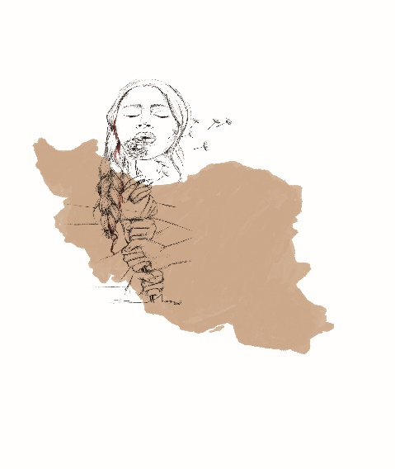
- Reach out to influencers, celebrities, and public figures to engage them in supporting the campaign and amplifying its message to increase visibility.
Letter/ Press Release to Politicians …. About the campaign
Your Name]
[Your Address]
[City, State, Zip Code]
[Email Address]
[Phone Number]
[Date]

[Politician's Name]
[Title/Position]
[Address]
[City, State, Zip Code]

Subject: Join the Global Action for Hope For Freedom, Mahsa Jina Amini
Dear [Politician's Name],

I hope this letter finds you in good health and spirits. My name is [Your Name], and I am writing to invite you to join a significant global action: Hope For Freedom, Mahsa Jina Amini.
In Iran, both women and men face substantial challenges to their freedom and basic rights due to discriminatory laws and cultural norms that restrict their autonomy and pursuit of a just society. The campaign "Hope For Freedom, Mahsa Jina Amini" aims to raise awareness and support their struggle for hope and freedom. We believe that by advocating for equality, breaking down barriers, and standing together with the people of Iran, we can create a world where human rights are upheld, and everyone can flourish without fear of discrimination or repression.
As a respected political figure, your participation in this campaign would have a significant impact in amplifying their voices and garnering support for their cause. We kindly invite you to engage in the following initiatives as part of this campaign:
1. Cutting (Hair) for Hope
Encourage the worldwide community to cut their hair as a symbol of solidarity with the movement in Iran. By sharing their stories and messages using hashtags #Mahsaamini and #HopeForFreedom, we can create a supportive community that highlights the challenges faced by Iranian women. Utilizing social media platforms such as Instagram, Twitter, and Facebook will allow us to reach a broader audience and spread awareness effectively.

2. Memorial Vigil for Hope
Organize a candlelight and flower vigil in your town's city center on the anniversary of Mahsa Amini's death, spanning a period of two weeks. By placing pictures and letters inviting people to join the campaign through candle lights and flowers, we can create a visual display of solidarity. The creation of an interactive virtual map will visually showcase the impact of the memorial vigil, allowing people to engage with the campaign and amplify its message.
3. Letter of Hope
Join the campaign by signing a letter that sends messages of encouragement and empowerment to women in Iran. These heartfelt messages will show solidarity and remind them that they are not alone in their struggle for freedom and justice. Your participation in this initiative will be an acknowledgment of the challenges faced by the people of Iran and a testament to your dedication to human rights and social justice.
By actively participating in the "Hope For Freedom, Mahsa Jina Amini" campaign, we can collectively advocate for a brighter future where gender equality and human rights are upheld in Iran. Your support will be instrumental in raising awareness and showing solidarity with those striving for hope and freedom.
We have attached more information about the campaign initiatives to this letter. Should you have any questions or require additional details, please do not hesitate to contact me at [Your Email Address] or [Your Phone Number].
We sincerely hope that you will join us in this vital campaign to stand hand in hand with the people of Iran on their journey towards a more just and equitable society.
Thank you for considering this invitation. We look forward to your positive response.
Sincerely,

[Your Name]

Action Plan: Hope for Freedom, Mahsa Jina Amini
Objective: The goal of this action plan is to raise awareness and support the struggle for hope and freedom in Iran, advocating for equality, breaking down barriers, and creating a world where human rights are upheld.
- Campaign Launch and Awareness
- Design and launch a dedicated website and social media channels for the "Hope for Freedom" campaign.
- Create powerful visuals and graphics to represent the movement's essence and share them on social media platforms.
- Use press releases, interviews, and outreach to media outlets to generate widespread coverage and support.
- Letter to individuals.
- Invite by letter individuals, politicians, celebrities, influencers, and activists to participate in the campaign.
- Create localized campaign materials and translate them into different languages to broaden participation.
- Detail of Campaign
  - Cutting (Hair) for Hope
- Timeline: 1st -15th of September
- Encourage individuals, politicians, influencers, activists, and celebrities ,… to take a video and share their haircut on social media.
- Promote and post the video of hashtags #Mahsaamini and #HopeForFreedom to create a supportive online community.
  - Memorial Vigil for Hope
- Timeline: 1st -15th of September
- Collaborate with local communities and activists to organize candlelight and flower vigils on the anniversary of Mahsa Amini's death.
- Provide guidelines on the memorial sites to inform the people how they can join the campaign by taking pictures, posting and #HopeForFreedom.
- We will create an interactive virtual map that showcases the location of the memorial vigil.
  - Letter of Hope
- Create the letter of hope on the website where everyone can sign the letter to show support the campaign and the messages of encouragement and empowerment to women in Iran.
- Develop an online platform where individuals can sign the letter of hope, sending messages of encouragement and empowerment to women in Iran.
- Encourage public figures and politicians to endorse and sign the letter, showing solidarity with the movement.
- Compile the heartfelt messages into a digital book or video and share them on social media to amplify their impact.
- Target groups
- Collaborate with Prominent Public Figures, human rights organizations, women's rights groups, activist, politicians, and NGOs working in Iran to strengthen the campaign's impact.
- Seek endorsements and support from influential organizations and personalities to gain greater visibility.
4. Monitor and Evaluate
- Regularly post informative content, success stories, and updates on campaign initiatives on social media platforms.
- Utilize informative posts, graphics, and videos to highlight Iranian women's challenges and progress made through the campaign.
- Track the campaign's reach, engagement, and impact using social media analytics and online surveys.
- Analyze feedback and adjust the campaign strategy as needed to optimize its effectiveness.

By implementing this action plan, the "Hope For Freedom, Mahsa Jina Amini" campaign can galvanize support and create a global movement that stands in solidarity with the people of Iran. Together, we can advocate for a brighter future where freedom, equality, and human rights prevail. #HopeForIranFreedom #StandWithIran #GenderEquality #HumanRights

Twitter text
🌟 Join the campaign for #HopeForFreedom in honor of Mahsa Jina Amini. Stand with brave Iranian people raise awareness, and advocate for equality, freedom.
Let's create a brighter future where freedom and human rights prevail.

🌟 Join the Global Action for #HopeForIranFreedom in honor of Mahsa Jina Amini and the Women Freedom Revolution! Stand with Iranian women and men, raise awareness, and advocate for equality. Let's break barriers together!

